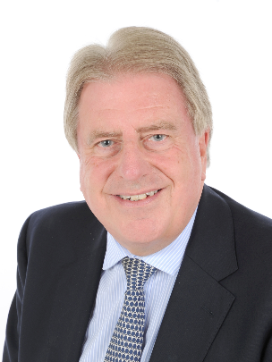

DAVID EVENNETT
CONSERVATIVE PARLIAMENTARY CANDIDATE FOR BEXLEYHEATH AND CRAYFORD

CONTACT DETAILS:

ADDRESS 17 CHURCH ROAD, BEXLEYHEATH, KENT. DA7 4DD

EMAIL davidevennett@gmail.com

TELEPHONE 0208 303 4695

BIOGRAPHY

MP for Bexleyheath & Crayford 2005 – 2017.
Lord Commissioner for HM Treasury since 2012 (Government Minister).
Lives in Barnehurst with his wife Marilyn, and has two sons and two grandchildren.
Active member of St. Paulinus Church, Crayford, Patron of Townley Grammar School, Vice-President of Bexleyheath and District Club for the Disabled and active supporter of Greenwich and Bexley Hospice and BCU Life Skills.

